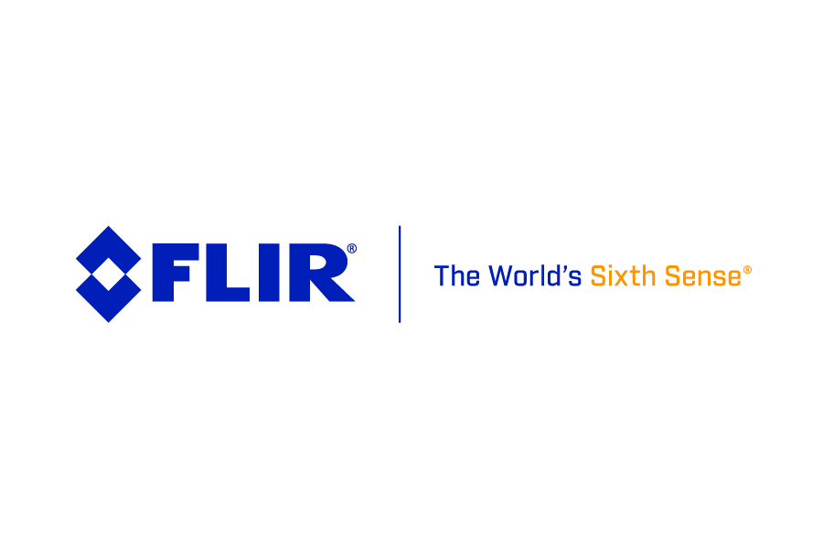

Contact: Ruud Heijsman – FLIR
Monday June 5th, 2017 +32 3665 5100 or ruud.heijsman@flir.com

FLIR Announces FLIR Griffin G510 Portable Gas Chromatograph-Mass Spectrometer for Chemical Hazard Identification
Integrated Survey Mode and Liquid Injector Provide Onsite Analysis of Solid, Liquid and Vapor Threats

WILSONVILLE, Ore. – June 5, 2017 – FLIR Systems, Inc. (NASDAQ: FLIR) today announced the Griffin G510 Gas Chromatograph-Mass Spectrometer (GC/MS), its first person-portable chemical identifier. The FLIR Griffin G510 enables military and civil responders to easily sample all phases of matter, including solid, liquid, and vapor, to rapidly identify chemical hazards in the field. The versatile Griffin G510 represents a new-generation of portable GC/MS capability, with multiple integrated sample inlets that simplify on-scene analysis and a technology core that delivers actionable, lab-caliber answers.

The FLIR Griffin G510 comes equipped with an integrated heated sample probe designed for downrange missions. When used in survey mode, it identifies vapor-phase chemicals within seconds. The split/split-less injector allows for environmental, forensic, and hazardous material sampling by enabling syringe injection of organic liquids, a first for person-portable GC/MS systems.

Featuring a nine-inch touchscreen, the FLIR Griffin G510 can be operated while wearing full personal protective equipment when in a hot zone. When a chemical threat is automatically identified using industry-standard NIST library, the FLIR Griffin G510 alerts the operator with audible, visual, and color-coded alarms. Designed to withstand harsh environments, the FLIR Griffin G510 is IP65-rated, dust-tight and spray-resistant. Long-lasting, onboard, rechargeable batteries ensure every mission receives support from beginning to end.

“The FLIR Griffin G510 is a groundbreaking chemical analysis tool that brings versatility and lab quality performance and identification to the field.” said Dennis Barket, Jr., Vice President and General Manager of FLIR Detection. “The ability to quickly identify unknown threats and confirm known hazards gives responders confidence to take immediate action, ensuring the public’s safety.”

FLIR will showcase the FLIR Griffin G510 at the International Hazardous Materials Response Teams Conference hosted by the International Association of Fire Chiefs (IAFC) June 16-17, 2017 in Baltimore, Maryland, booth #1153 and at the NCT show, June 27-29, 2017 in Sonthofen, Germany, booth #38. The FLIR Griffin G510 will be available for order worldwide in the second half of 2017 through FLIR and established distribution networks. To learn more about the FLIR Griffin G510, please visit: www.flir.com/G510

About FLIR Systems, Inc.
Founded in 1978 and headquartered in Wilsonville, Oregon, FLIR Systems is a world-leading maker of sensor systems that enhance perception and heighten awareness, helping to save lives, improve productivity, and protect the environment. Through its nearly 3,500 employees, FLIR’s vision is to be “The World’s Sixth Sense” by leveraging thermal imaging and adjacent technologies to provide innovative, intelligent solutions for security and surveillance, environmental and condition monitoring, outdoor recreation, machine vision, navigation, and advanced threat detection. For more information, please visit www.flir.com and follow @flir.

