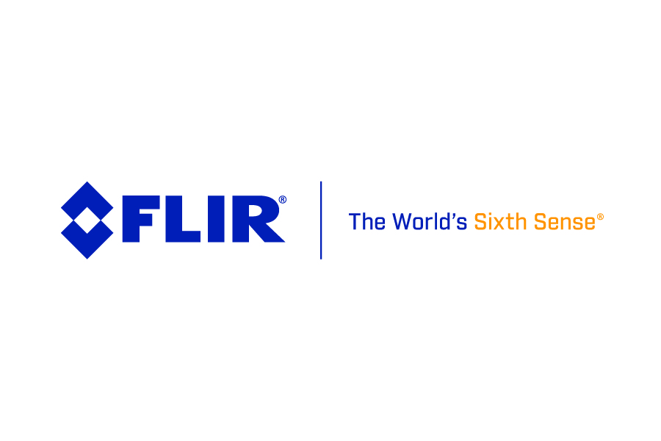

**Added Value Thermal Imaging**

**WILSONVILLE, Oregon, USA, 29.10.2018** - Whether you are a builder or electrician new to thermal imaging or someone who already appreciates the power of the technology and wants more functionality, FLIR Systems has good news for you. From 15th October 2018 to the end of this year, the company is running an incentive programme that also includes special, cost-saving product bundles.

The FLIR C3 is a powerful, fully-featured, pocket-sized thermal camera designed for a wide range of building and electrical/mechanical applications. Its slim, light profile fits comfortably into any work pocket so the camera is instantly available for troubleshooting.

In common with most models in the FLIR Systems’ range, it also includes the company’s unique MSX® technology. This adds key details from the on-board visible camera to the entire infrared image in real time making problem diagnosis easy and quick. Area minimum and maximum temperature measurement and Wi-Fi connectivity are also standard features.

During this promotional period, the FLIR C3 is either available as a stand-alone product that carries a 16% discount or as part of two product bundles. The first is aimed at electricians and combines the FLIR C3 with a FLIR VP52, non-contact voltage detector with work light. This rugged, waterproof and CAT IV-rated instrument also features vibration feedback and multi-coloured LED alarms.

For building professionals, the second bundle teams the FLIR C3 with a FLIR MR40 2-pin, single-scale moisture meter. It is a quick and easy-to-use tool to find and quantify moisture. Both bundles represent an overall cost saving of 17% and are priced at 610€ (excl. VAT) and 639€ (excl. VAT) respectively.

Cost savings of up to 6% are also available on the models in the FLIR Ex-Series troubleshooting range and an 18% price reduction is being applied to the entry-level FLIR C2. For further information visit: <https://www.flir.eu/promotions/instruments>

**AboutFLIR Systems**  
*Founded in 1978 and headquartered in Wilsonville, Oregon, FLIR Systems is a world-leading maker of sensor systems that enhance perception and heighten awareness, helping to save lives, improve productivity, and protect the environment. Through its nearly 3,500 employees, FLIR's vision is to be "The World's Sixth Sense" by leveraging thermal imaging and adjacent technologies to provide innovative, intelligent solutions for security and surveillance, environmental and condition monitoring, outdoor recreation, machine vision, navigation, and advanced threat detection. For more information, please visit*[www.flir.com](https://www.globenewswire.com/Tracker?data=UHRLueMCI9_8asN41MKABIjNPBLQzanbXdhtpIOXN3sxyyudek09u5QFiwjbK0gqJD0xbuY7CLJ86Uq4buNPpQ==)*and follow*[@flir](https://www.globenewswire.com/Tracker?data=J4yZ9Qmw39HLIXnkM3u9C6px5jGxUEv8lFLEg95w0eamb9qXDLbR8PAPg2X44Zt4LE-kpLVR1SdWWOArZblhqg==)*.*

**Information on FLIR thermal imaging cameras:**

FLIR Systems GmbH, Berner Straße 81, 60437 Frankfurt, Tel.: 069/950090-0, Fax: -40, E-Mail: [info@flir.de](mailto:info@flir.de) [www.flir.com](http://www.flir.com) [www.irtraining.eu](http://www.irtraining.eu) [www.flir.de/mv](http://www.flir.de/mv) [www.flir.eu](http://www.flir.eu)

**Contact for text, images, application stories and technical notes:** ABL Werbung Frank Liebelt, Kellerskopfweg 13, 65931 Frankfurt, Tel.: 069/501717, E-Mail: [frankliebelt@ablwerbung.de](mailto:frankliebelt@ablwerbung.de)

**Other (German) press releases by FLIR:** http://www.ablwerbung.de/presse04.html

**Application stories:** <http://www.flirmedia.com/flir-instruments.html> Select the segment – Science/R&D, Building, Industrial, Automation – and click on "Application stories" or "Technical Notes".