Wednesday, September 29, 2021

**Teledyne FLIR Expands Acoustic Imaging Offerings with Two Additional Si124 Camera Models**

***The Si124-PD, for Partial Discharge Detection, and Si124-LD, for Air Leak Detection, Provide Customers Specialized Operations for a Greater Return on Investment***

Teledyne FLIR has expanded its acoustic imaging category with two additional models of the FLIR Si124 Industrial Acoustic Imaging Camera: The Si124-LD, specific for compressed air leak detection, and the Si124-PD, for partial discharge detection within high voltage electrical systems. This expansion provides additional, tailored solutions for different end-users needs, from utility infrastructure to plant environments, at a fraction of the cost.

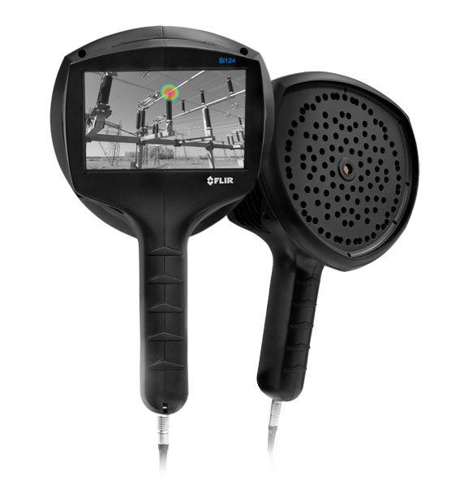

The FLIR Si124-PD and Si124-LD devices also include easy-to-use onboard analytics with access to an online portal through the FLIR Acoustic Camera Viewer cloud service. This software empowers users to perform both quick diagnostics tasks and conduct deeper analysis. With this data, Si124-PD users can determine the severity of partial discharge issues in high voltage equipment, improving electrical grid reliability. Likewise, the Si124-LD model helps users determine the severity of compressed air leaks, potentially saving tens of thousands of dollars in energy costs.

“The FLIR Si124 acoustic imaging family of cameras provides for more precise issue detection by offering an unrivaled number of integrated microphones with improved microphone signal-to-noise ratio as well as a top detection frequency of 35 kHz to help users further pinpoint problem areas,” said Rob Milner, Global Business Development Manager – Condition Monitoring, Teledyne FLIR. “The Si124-PD and LD editions features the same robust artificial intelligence software capabilities of the Si124, but are customized to provide a more economical option for particular uses, such as locating corona at a utility substation or compressed air leaks in a factory setting. Taken together, the family of Si124 devices can help reduce inspection times up to 10x versus traditional methods.”

**Si124-PD for Partial Discharge Detection**

The new Si124-PD features automatic electrical fault classification for partial discharge issues, including surface, discharge, floating discharge, and discharge into air. With the PD Severity Assessment software feature, users can also input the kind of component, the equipment voltage, and the distance from the component to get a severity assessment specific to those parameters. This feature is included within the FLIR Acoustic Camera Viewer cloud software.

Furthermore, users can safely detect problems from distances up to 130 meters (430 feet) with the flexibility to operate the device with one hand. Operators can also easily review images on-screen, even in bright, outdoor conditions.

**Si124-LD for Compressed Air Leak Detection**

The Si124-LD features real-time, on-device leak sizing and cost analytics, allowing users to instantly view the leak rate onscreen as it occurs, either in liters per minute (l/min) or cubic feet per minute (CFM), and to quantify leak size. This feature provides a quick assessment of how much air is being lost and estimated cost savings from fixing the issue. By incorporating the Si124-LD as part of a regular maintenance program, organizations can extend the life and efficiency of existing compressors while reducing the need to install new units and lowering electricity costs.

The FLIR Si124-PD, Si124-LD, and the original Si124 Industrial Acoustic Imaging Camera models are available for purchase globally from Teledyne FLIR and its authorized dealers. To learn more or to purchase, visit <https://www.flir.com/products/si124>.