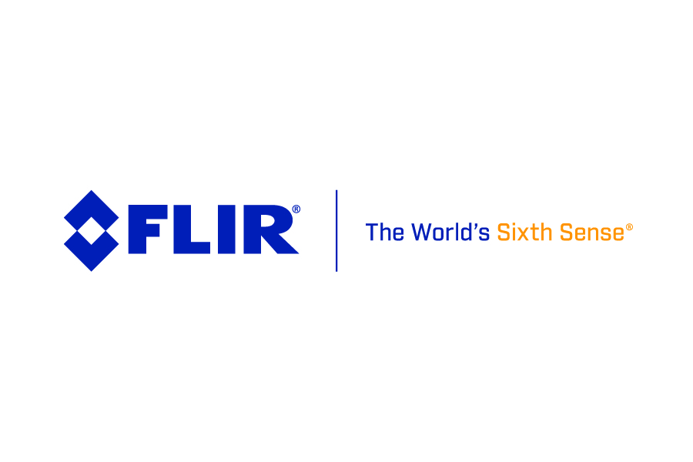
New FLIR GF77 Gas Find IR Series Increases the Versatility of FLIR’s Uncooled Gas Detection Solutions

Building on the previous methane-detecting GF77 camera release, FLIR now offers two lens types for finding a wider variety of gases with just one camera

The new FLIR GF77™ Gas Find IR Series provides professionals with the flexibility to use one uncooled gas detection camera for gas detection and thermal inspections across chemical and industrial manufacturing, electric power utilities, natural gas supply chain, food and agricultural, and public safety. The most notable feature updates include visualizing a completely new category of gases in sulfur hexafluoride, ammonia, and ethylene. The GF77 Series also offers IR high-temp ranges, increased temperature measurement accuracy and improved inspection flow/reporting with optional add-ons for FLIR Thermal Studio Pro and FLIR Route Creator.

The versatile GF77 does more than visualize gases; this ergonomic, easy to use camera is calibrated for IR temperature measurement, so inspectors can use it as part of predictive maintenance programs, such as verifying tank levels and searching for electrical or mechanical issues without the need to change a lens.

New Lens Options
The GF77 Gas Find IR Series offers two types of lenses—low-range (LR) and high-range (HR)—in a standard 25° field of view or as a 6° telephoto lens. The LR lens has a built-in 7–8.5 µm wavelength filter for visualizing methane, nitrous oxide, sulfur dioxide, R-134a, and R-152a. The HR lens filters the 9.5–12 µm wavelength for visualizing sulfur hexafluoride, ammonia, and ethylene.

Professionals have the option to purchase the lens combination that meets their needs, the GF77-LR, the GF77-HR or the GF77 with both the LR and HR lenses. Further, each lens is calibrated to a specific camera body at the time of purchase to visualize the gases of interest and measure temperature accurately.

For customers who already own a GF77 and would like to expand its capabilities, the FLIR service center can calibrate any new lens purchased for that specific device.

Improved Camera Options
The GF77 Gas Find IR Series now includes a broader temperature detection range, from -20 °C to 500 °C, with improved accuracy of +/- 3 °C, down from +/- 5 °C, within the full temperature range. The optional on-board routing capability, Route Creator, allows end-users to simplify surveys by pre-planning the route that includes a list of assets that need to be inspected at each location, reducing the risk of missing an asset that could lead to an unexpected failure. The reporting add-on, Thermal Studio Pro, offers an easy final comprehensive report option.

The GF77 Gas Find IR Series is available globally. For more information, including options for purchasing, visit: www.flir.com/GF77-series.

-###-
About FLIR Systems, Inc.
Founded in 1978, FLIR Systems is a world-leading industrial technology company focused on intelligent sensing solutions for defense, industrial and commercial applications. FLIR Systems’ vision is to be “The World’s Sixth Sense,” creating technologies to help professionals make more informed decisions that save lives and livelihoods. For more information, please visit www.flir.com and follow @flir.

