

FLIR INDUSTRY ANNOUNCEMENT

**Training Videos for CBRNE Professionals**

**FLIR Systems** announces a new and highly informative CBRNE (Chemical, Biological, Radiological, Nuclear, and Explosive materials) training video series - **FLIR PRIMED.**

Available in English, French, German and Italian - FLIR PRIMED videos are a free, educational resource designed to provide first responders and security professionals with best practices for HAZMAT accidents and CBRNE attacks.

Throughout the video series, Grant Coffey, a retired Fire & Rescue Hazmat Team Coordinator and CBRNE expert of nearly 40 years, delivers best practices, industry insights, and street truth. In addition, each video concludes with a field checklist that responders can use right now. The first 5 episodes are available now for viewing at [www.flir.co.uk/PRIMED](http://www.flir.co.uk/PRIMED), [www.flir.fr/PRIMED](http://www.flir.fr/PRIMED), [www.flir.de/PRIMED](http://www.flir.de/PRIMED) and [www.flir.it/PRIMED](http://www.flir.it/PRIMED).

FLIR PRIMED episode 1 introduces the video series and the importance of CBRNE best practice using the Prepare, Recognize, Input, Monitor, Experience and Decision methodology.

FLIR PRIMED episode 4 focuses on Explosives 101. Explosives are one of the weapons of choice for terrorists. They are easy to make and easy to trigger. This **episode discusses the key actions and considerations at an explosive scene.**

FLIR PRIMED episode 5 discusses Bio-Agents. Biological agents are some of the most toxic substances known to man. But unlike other agents, their effects are usually delayed and can spread like wildfire unseen. This episode covers appropriate personal protective equipment and what actions to take at a suspected biothreat scene.

Moving forward, every 2 months, 5 new FLIR PRIMED video will be available describing best practices, industry insights, and real-life experiences to help you stay prepared. Each episode will be accompanied by a field checklist or downloadable guide that you can use right now.

For further information contact FLIR Systems in Europe on +32-3665-5100 or [primed@flir.com](mailto:primed@flir.com).

Founded in 1978 and headquartered in Wilsonville, Oregon, FLIR Systems is a world-leading maker of sensor systems that enhance perception and heighten awareness, helping to save lives, improve productivity, and protect the environment. Through its nearly 3,500 employees, FLIR’s vision is to be “The World’s Sixth Sense” by leveraging thermal imaging and adjacent technologies to provide innovative, intelligent solutions for security and surveillance, environmental and condition monitoring, outdoor recreation, machine vision, navigation, and advanced threat detection. For more information, please visit [www.flir.com](http://www.flir.com/) and follow [@flir](https://twitter.com/flir).

**SEPTEMBER 2017 Reference: PR166**

**Illustrative Images** (available on request)

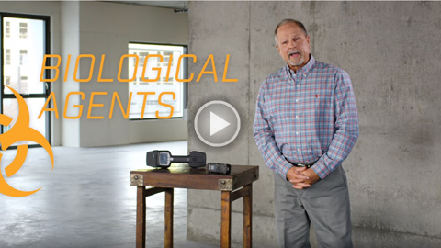

Caption: FLIR PRIMED Episode 5

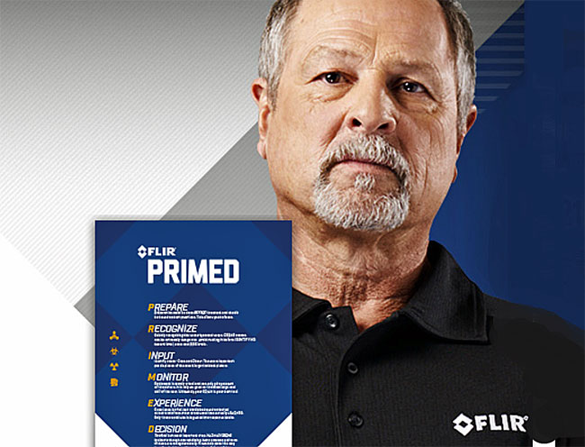

Caption: Grant Coffey, FLIR PRIMED instructor