*July 24th.2023 Dahua Case Study: The DeepHub Whiteboard in School Use*

**Dahua DeepHub Whiteboard in use at ISR International School on the Rhine**

**In Neuss, Düsseldorf and Meerbusch, ISR (International School on the Rhine) offers an excellent international education from kindergarten to grade 12. The teachers at ISR prepare students for the world's most prestigious universities, placing great emphasis not only on academic excellence, but also on positive character development and the teaching of values. Since 2022, ISR has also been using the DeepHub whiteboard for this purpose.**

**Test phase from 2022**

"The modernization of classrooms and the additional digitalization of teaching methods are important concerns for us," explains Peter Soliman, Managing Partner of ISR. "Dahua's DeepHub whiteboard offers us versatile functionalities and the perfect solution for our needs." Mohammed Aloof, Head of IT at ISR, adds, "We have already deployed the DeepHub whiteboards in some classrooms since 2022. The feedback we have received from teachers and our students has been extremely positive. Therefore, we have decided to install a more modern whiteboard in every classroom for even better learning conditions.

**Improved visibility and interaction**

The new whiteboards have significantly improved the visibility of the learning content. Students can now read the text on the screen very well from all angles of the classroom. And thanks to the optimized brightness of the screen, classrooms no longer need to be darkened.

"Being able to add handwritten information to documents on the whiteboard adds a lot of value for me," adds Bianca McLeod, a teacher at ISR and head of secondary education. "The sensitivity here is just right. For example, I can also call up pre-made geometric shapes and use them for lessons. The whiteboard function allows me to save the pages afterwards and call them up again at any time. And the students can save the learning content by scanning a QR code. Our teachers can also upload and use extensive materials and teaching aids on DeepHub, which is very practical and accommodates an increasingly paperless - and thus environmentally friendly - aspiration at ISR."

Classroom interaction is also further encouraged with the DeepHub. For example, teachers encourage students to participate directly via the whiteboard and answer the quiz displayed on the DeepHub screen. This two-way sharing system between DeepHub and the students' tablets is particularly practical and allows for innovative and interactive teaching.

"After almost a year of experience with DeepHub, I have noticed a positive change in my teaching," Ms McLeod points out. "The students have become more engaged and even more proactive. We are convinced that further upgrading of the screens will bring even more benefits!"

**Administration work is simplified**

The head of the IT department at ISR, Mr. Aloof, is also satisfied: "The Dahua DeepHub makes administration very easy. A highly modern DeepHub device now replaces the old equipment, projector, speakers, microphone, countless cables and much more. It makes the management work much easier."

**Clever all-in-one solution**

The DeepHub whiteboard ensures excellent presentation experiences and creative ideation by allowing participants to fully concentrate on the task at hand without having to worry about technical aspects. In doing so, its 4K 3840×2160 touch UHD display with a screen diagonal of 65 to 98 inches and a and 178° viewing angle, combined with anti-glare technology, ensures a clear, more legible display, sharp images and vivid colors.

One-touch projection from up to four terminals via the USB wireless screen sharing dongle or eshare software simplifies collaborative presentations. In training situations and in the classroom, knowledge can be conveyed intuitively and with fun in this way. At the same time, as part of a quality control process, other teachers as well as academic coordinators have the opportunity to participate in lessons from any location with internet access, even if they are not on site, thanks to the interactive features.

**High-quality, interactive touch screen**

The touch-active screen supports an optimal writing experience: Smooth writing works virtually in real time with less than ten ms latency. Responses to touch and support for simultaneous writing vary depending on the application. The integrated camera (up to 5MP) and up to eight microphones enable powerful video conferencing. Thanks to its high audio and video quality, the Dahua interactive whiteboard is also suitable for seminars, business negotiations and training.

**Compatibility**

Of course, comprehensive compatibility is also taken care of: the pre-installed Android and an optional Windows operating system enable the use of a wide range of productivity tools. This makes perfect sense, as dual operating systems offer a wide range of apps and software. The device is also compatible with popular third-party video conferencing software. Its competitive price and a three-year warranty ensure a high return on investment. In addition, the integrated Android as well as an optional Windows operating system ensure full compatibility with numerous teaching and learning programs.

**Conclusion**

"ISR has many Dahua products in use. In the past, our security system, but now also state-of-the-art interactive whiteboard technology in all classrooms. We are grateful for the support from a global leader in technology and IoT solutions," explains Peter Soliman, concluding: "I am convinced that the new technology will add great value to ISR's students."

Link to the video: <https://www.youtube.com/watch?v=eU-Uwt-grxQ>

Link to all images for this case study: <http://www.ablwerbung.de/download/Dahua/ISR-alle-Bilder.zip>

**Dahua:**

With a global marketing and service network, Dahua Technology has established more than 200 China offices as well as 67 overseas subsidiaries, branches and representative offices covering Asia, North America, South America, Europe, Africa, Oceania and other regions to provide customers with speedy and high-quality services. In addition, Dahua Technology has deployed its products, solutions, and services in 180+ countries and regions, covering key vertical industries such as transportation, manufacturing, education, retail, banking & finance, energy, environmental protection, etc. Committed to technological innovation, Dahua invests approximately 10% of its sales revenue to R&D every year. By 2022, the company has also applied for over 8,000 patents, including more than 390 international patents. Dahua Technology GmbH in Düsseldorf coordinates sales and marketing for Germany, Austria and Switzerland. More at www.dahuasecurity.com/de and dahuasecurity.de

**ISR International School on the Rhine**

ISR International School on the Rhine GmbH, based in Neuss, is a privately run international all-day school. Over 1,000 students from the region and around the world prepare together for internationally recognized school qualifications. Academic excellence and character building are at the heart of the education, qualifying students for study at leading universities in Germany and around the world. For younger children, ISR offers an international kindergarten on the ISR campus in Neuss, in Düsseldorf-Niederkassel as well as a German-speaking branch in Meerbusch-Büderich. Enquiries about kindergarten, primary school and secondary school are accepted all year round: admissions@isr-school.de.

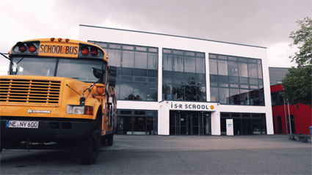

Image 1: In Neuss, Düsseldorf and Meerbusch, ISR (International School on the Rhine) offers an excellent international education.

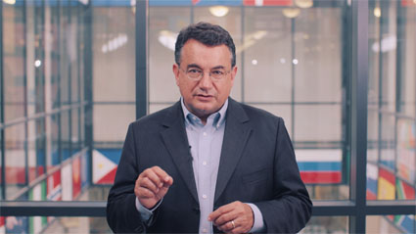

Image 2: Peter Soliman, Managing Partner of ISR.



Image 3: Bianca McLeod, a teacher at ISR and head of secondary education.

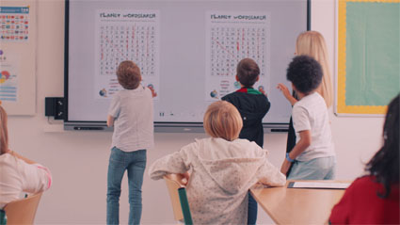

Image 4: Students participate directly via the whiteboard and answer the quiz displayed on the DeepHub screen

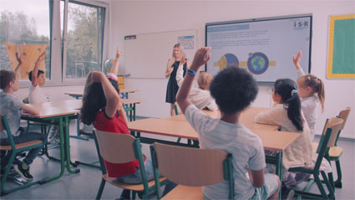

Image 5: Classroom interaction is also further encouraged with the DeepHub